1. Delete files from DatabaseTask.Core and DatabaseTask.Core (including employee.cs)
2. Create „PersonDatabase“ in MS SQL. It should look like this: 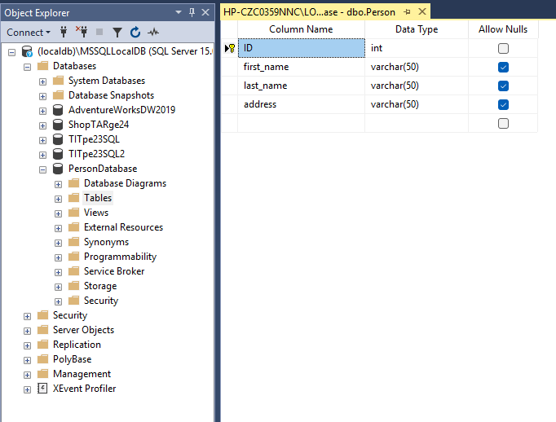
3. Add the following to appsettings.json :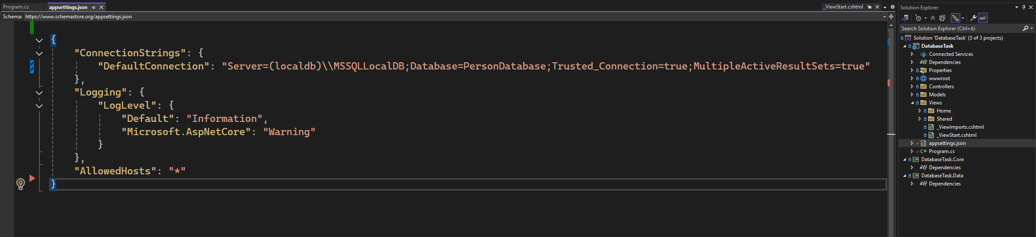
4. Go to „Package Manager Console“ with search function inside Visual Studio and throw following script: 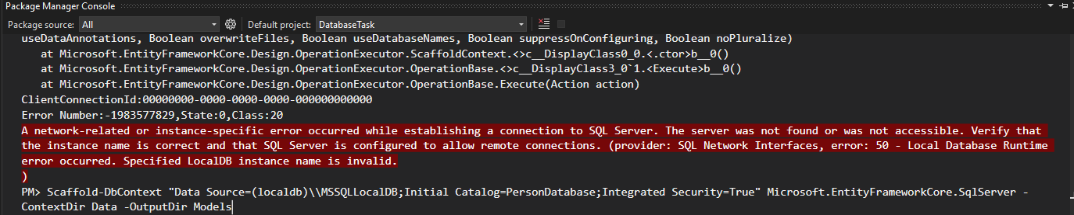
5. If you get following red error in console, that means something is blocking script from completion. Otherwise should be correct.